INDUSTRIAL TRAINING

EXPENSE TRCKING

Session – 2022-23

B.TECH CSE (A)

02/12/2022

Project Guide: Submitted By:

Ashish Bishnoi Neha Verma

TCA – 1909064

Faculty Of Engineering

TEERTHANKER MAHAVEER UNIVERSITY, MORADABAD

TABLE OF CONTANT

1. Project title
2. Language and software tool used
3. Objective of project
4. Project description
5. Characteristics of project
6. Implementation of methodology
7. Case diagram
8. Technology used
9. Hardware platform

10.Why we choose this project

SYNOPSIS

PROJECT TITLE:

Food ordering system

LANGUAGE AND SOFTWARE TOOL USED:

LANGUAGE: Python

OPERATING System: Window 11

OBJECTIVE OF PROJECT:

The objective of the project is to develop a user-friendly GUI based billing system.The application can be accessed and effectively used by the user. The billing system contains the menu which is available in the restaurant. The owner or the cashier has to check the item ordered by the customer and enter the number of orders given for a particular item in the menu. Once the items are selected, the cashier can automatically get the total and the receipt will be generated.

**Project Description:**

The project has been implemented in python. The system contains the menu which is

available in the restaurant. The owner or the cashier has to check the item ordered by the

customer and enter the number of orders given for a particular item in the menu. Once the items are selected, the cashier can click on total to obtain the total for drinks and the food separately.

It displays the service charges and the tax also. When the cashier clicks on the receipt button, the receipt is generated.

**Characteristics of Project:**

1. **Fast**:

Food ordering system provides us the functionality for making the calculations in a fast manner so that this will save our time as we know that time is very essential for us.

1. **More accuracy:**

It gives us more accuracy because the work that is done in it is done by the computer not by the particular person. It gives the correct value according to the ordered that has been ordered by the customers.

1. **No misunderstanding:**

Through this system the calculation of the amounts of food that have been ordered will be very simple and here is no chance of misunderstanding.

1. Very less paper work:

Expense Tracking System requires less paper work. In this project all record is fetched directly into the computer and result can be generated through just a click. In this way it saves time. As data is directly entered into computer so there is no need to do any paper work.

**Implementation of methodology:**

**Flow chart:**

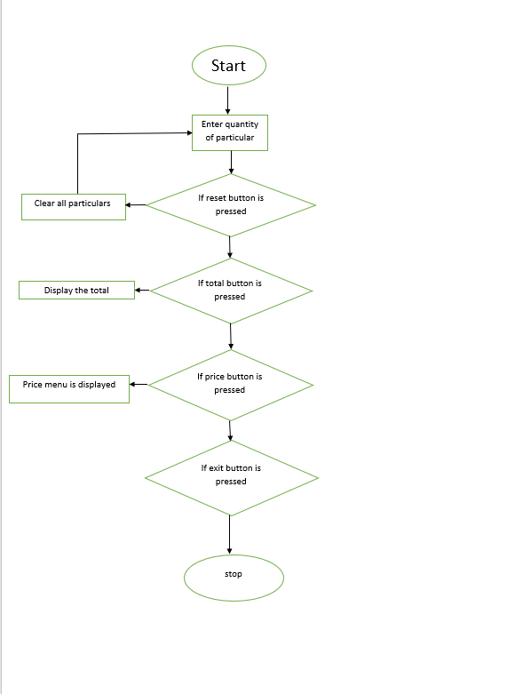

**USE CASE DIAGRAM**

h

b

## 

## ***TECHNOLOGY USED***

**language**:

**Python**

Integrated Development Environment(IDE):

**Vs code**

## **Hardware Platform:**

### RAM _ 4gb

### Hard Disk - 256 GB

### OS - windows 10

### .

**Platform:**

Windows 10

**Why we choose this Project?**

We have choose this project because as we can see in our cities ,areas ,country there are lots of food point and restaurants where we can go and take the foods so managing the order manually and also their total amounts of the quantity that have ordered by the customer is complex because it is very difficult to manage this on paper because it will be very difficult for us if there are lots of order whose amount will be calculated so, this expense tracking system it will provide the facility to make the calculations easy so that there will be no change of mistake or calculation.

THANK YOU